Github Guide

1. Sign up and setup
- Sign up with this link https://github.com/join
- Download & install the github desktop here https://desktop.github.com/
- Sign in to the desktop.
- Click the Current repository button (yours will be blank)
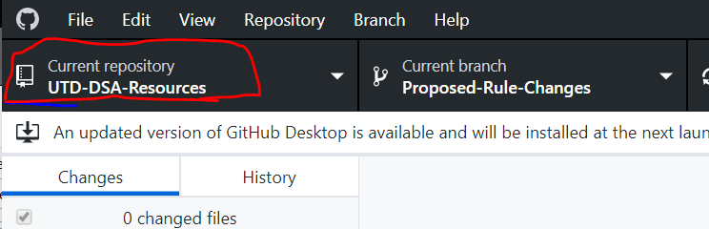

5. Click add, then clone repository
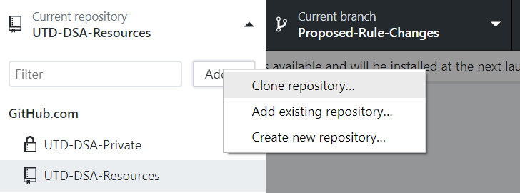

6. Switch to the url section, type in “utd-dsa/utd-dsa-resources,” and select where to download the
files to, then wait for download

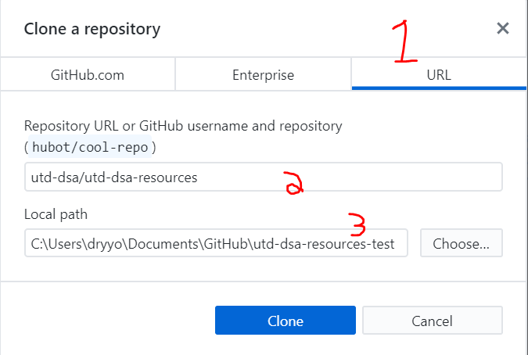

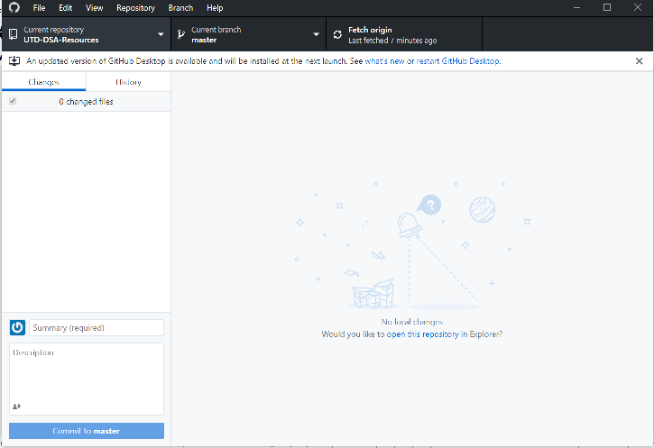
7. Your page should look something like this now. Welcome to the utd-dsa github!

2. What is this thing?

Think of github as a shared google drive, but instead of enabling everyone to edit the same documents, it enables everyone to edit copies of the document and combine those easily to create new versions. Everyone has their own “repository” - the set of documents and edits you’ve done to them, and there’s an official repository – the documents and all approved changes anyone has made to them. Github has a few main features you need to worry about.
- Pull – get the newest version of the repository from the online repository into your local repository. Edit them however you’d like, add new files, folders, whatever you want to do to make the club’s resources better
- Commit – when you’re done editing, hit this, and add a note describing your changes. This generates a file that shows your changes and adds it to your local repository.
- Pull request – send it off to the repository. Mods will get an alert that someone added some stuff. They’ll review it, and if it’s appropriate, they’ll “merge” it into the existing resources.
- Branch – github can maintain different branches of things. At inception, we have “master” (the official one), and “proposed-rules-changes.” The latter is for anything people want changed. Stuff there will be voted on, then merged into master if approved.
Github layout explainer:
